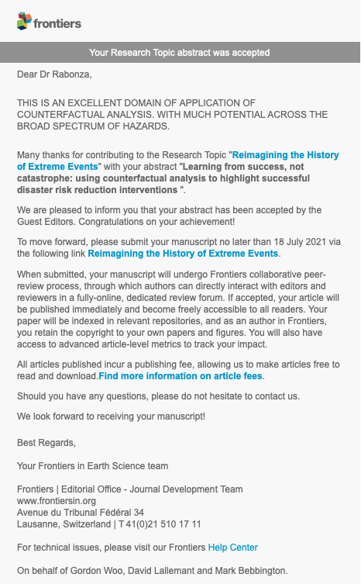

31 March 2021

Accepted abstract to Frontiers Special Issue:

"Reimagining the History of Extreme Events"

Abstract:

**Learning from success, not catastrophe: using counterfactual analysis to highlight successful disaster risk reduction interventions**

In the aftermath of a disaster, news and research attention is focussed almost entirely on catastrophic narratives and the various drivers that may have led to the disaster. Learning from failure is essential to preventing future disasters. However, hyperfixation on the catastrophe obscures potential successes at the local scale, which could serve as important examples and learning resource in effective risk mitigation.

We propose the use of *probabilistic downward counterfactual* analysis to highlight effective risk mitigation actions that would otherwise remain unnoticed amidst a disaster. This approach uses *counterfactual* modelling of a past hazard event with consequences made worse (i.e. *downward* counterfactual) by the absence of the mitigation intervention. We further apply the *probabilistic* risk analysis framework to associate estimated probabilities to simulated counterfactual outcomes. We demonstrate the approach using a case study of the school earthquake retrofitting program in Nepal, implemented before the 2015 earthquake. We calculate the probabilistic number of lives saved during the earthquake as a result of the retrofitting of 300 schools in Kathmandu valley since 1999.

The shift in focus from realised outcome to counterfactual alternative enables the quantification of the benefits of risk reduction activities amidst disaster. Such quantified counterfactual analysis can be used to celebrate successful risk reduction interventions, providing important positive reinforcement to decision-makers who have displayed political bravery in committing to the implementation of effective measures.